**Pradnya Bhalerao**

**Objective Questions**:

1. What is the total no. of tables present in the data?

**Ans- There is one table present in the data.**

1. What is the total no. of attributes present in the data?

**Ans- 35 attributes present in the data.**

1. The data consists of some inconsistent and missing values so ensure that the data used for further analysis is cleaned.

**Ans- 1. Handling Missing Values**

* **I Replaced missing values with 0 ensures numerical consistency, especially in cases where missing data indicates an absence of the recorded event or metric. This avoids errors in calculations during analysis.**

**2. Checking for Duplicate Records**

* Outcome: No duplicate records were found in the dataset, confirming that each entry was unique and no further deduplication was necessary.

3. Creating a Separate Date Column:

* **Methodology**:

The datetime column has combine so I split date and column. The Date column was isolated and formatted consistently (e.g., YYYY-MM-DD OR DD-MM-YYYY) for further analysis.

1. **Extracting Hours and Minutes from a Timestamp**  
   We have a column containing timestamps we can extract the hour using the HOUR function and the minute using the MINUTE function.
2. Creating separate columns for **Chat Hour**, **Chat Minute**, and **Call Hour** to enable filtering and grouping in PivotTables or charts. Using these fields to analyse trends, such as identifying peak chat hours and call activity by hour.

4. What is the change in daily call volume day by day and also find the average of daily call volume?

Ans- **Day 1**: There was a **decrease of 21** calls compared to the previous day.

**Day 2**: The call volume decreased by **45** calls from the previous day.

**Day 3**: The change was a decrease of **15** calls.

**Day 4**: A significant drop in call volume by **119** calls.

**Day 5**: Call volume dropped sharply by **190** calls.

**Day 6**: A slight increase of **2** calls from the previous day.

**Day 7**: There was a decrease of **71** calls.

**Day 8**: A small drop of **12** calls.

**Day 9**: An increase of **8** calls.

**Day 10**: A decrease of **7** calls.

**Day 11**: A small increase of **8** calls.

**Day 12**: A larger increase of **62** calls.

**Day 13**: An increase of **42** calls.

**Day 14**: A slight increase of **50** calls.

**Day 15**: A significant decrease of **95** calls.

**Day 16**: A small decrease of **11** calls.

**Day 17**: A large increase of **82** calls.

**Day 18**: A sharp increase of **120** calls.

**Day 19**: A decrease of **84** calls.

**Day 20**: An increase of **78** calls.

**Day 21**: A decrease of **86** calls.

**Day 22**: A drop of **18** calls.

**Day 23**: An increase of **27** calls.

**Day 24**: A significant increase of **86** calls.

**Day 25**: A decrease of **26** calls.

**Day 26**: An increase of **82** calls.

**Day 27**: A decrease of **19** calls.

**Day 28**: A drop of **92** calls.

**Day 29**: A decrease of **49** calls.

**Day 30**: A small decrease of **20** calls.

**Day 31**: A sharp decrease of **174** calls.

**Day 32**: A significant increase of **192** calls.

**Day 33**: A large decrease of **135** calls.

**The average daily change in call volume is** -13.6364.

And The average daily call volume is **52.47914511**

|  |  |
| --- | --- |
| **Row Labels** | **Average of CALL VOLUME** |
| 2023-12-01 | 55.05492424 |
| 2023-12-02 | 47.67196819 |
| 2023-12-03 | 50.73239437 |
| 2023-12-04 | 40.0698174 |
| 2023-12-05 | 35.93426573 |
| 2023-12-06 | 31.34799235 |
| 2023-12-07 | 21.83615819 |
| 2023-12-08 | 20.62130178 |
| 2023-12-09 | 22.62100457 |
| 2023-12-10 | 34.23905724 |
| 2023-12-11 | 33.58419244 |
| 2023-12-12 | 20.18918919 |
| 2023-12-13 | 23.92407108 |
| 2023-12-14 | 51.34242094 |
| 2023-12-15 | 83.16012085 |
| 2023-12-16 | 60.3907563 |
| 2023-12-17 | 88.0247578 |
| 2023-12-18 | 88.84543762 |
| 2023-12-19 | 51.34799235 |
| 2023-12-20 | 41.34385965 |
| 2023-12-21 | 44.5122549 |
| 2023-12-22 | 47.41032258 |
| 2023-12-23 | 67.35127479 |
| 2023-12-24 | 114.0311027 |
| 2023-12-25 | 57.53734062 |
| 2023-12-26 | 43.95544554 |
| 2023-12-27 | 42.04495504 |
| 2023-12-28 | 40.83101207 |
| 2023-12-29 | 46.56164384 |
| 2023-12-30 | 29.37532134 |
| 2023-12-31 | 85.50295858 |
| 2024-01-01 | 19.49846154 |
| 2024-01-02 | 47.53964497 |
| 2024-01-03 | 15.81300813 |
| **Grand Total** | **52.47914511** |

5. Which months experienced the highest and lowest call volumes?

Ans- According to given data, Dec 23’ getting highest calls than January .

1. What is the total operational cost for that month?

**Formula**

Operational Cost = Net Amount – Astrologer’s Earning

**Calculation:**

**December**

**Operational Cost =202214.62 - 93786.16**

**= 108428.45**

**January**

**Operational Cost = 11772.69 − 5360.41**

**= 6412.28**

The **Total Operational Cost for December** is **108428.45**

**The Total Operational Cost for January is 6412.28**

|  |  |
| --- | --- |
| **Row Labels** | **Sum of Operational Cost** |
| Jan | 6412.282 |
| Dec | 108428.4624 |
| **Grand Total** | **114840.7444** |

1. What is the average number of calls handled per agent per day?

Ans- Average calls per agent per day = total calls/ no. of days worked

8508/34=250.23

So the average call is 250.23

And the agent is 128

= 250.23/128=1.95

So the average no. of calls handled per agent per day is 1.9549.

1 or 2 call i.e. average call per day/total guru

**Here is the pivot table of date and count of no. of calls in a day**-

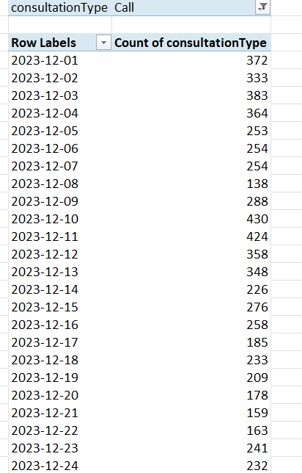

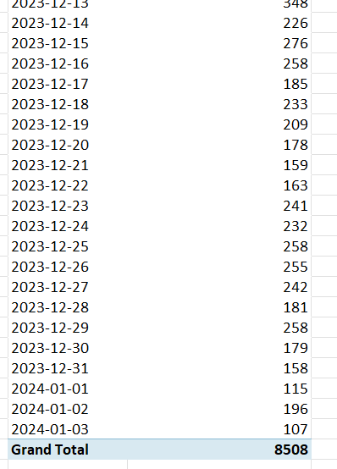

**Now guru name and their count of no. of callings**-

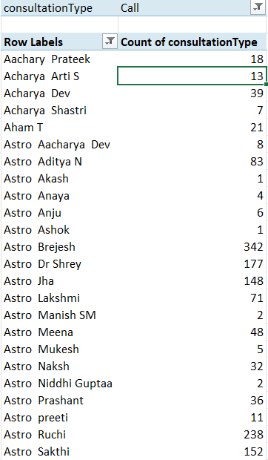

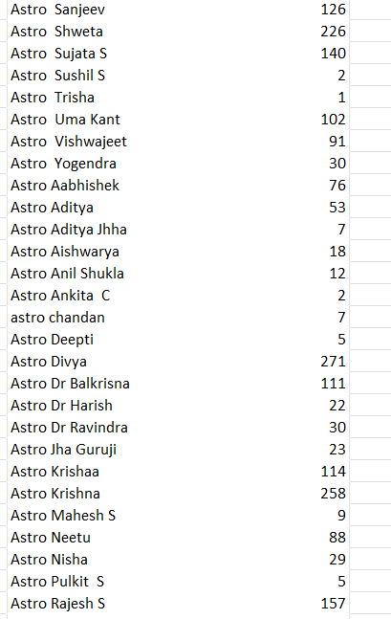

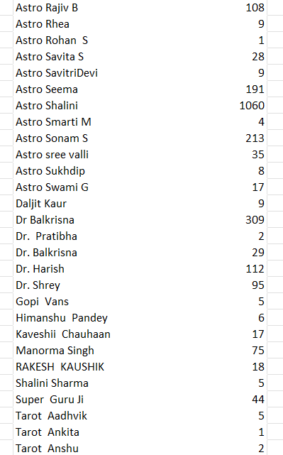 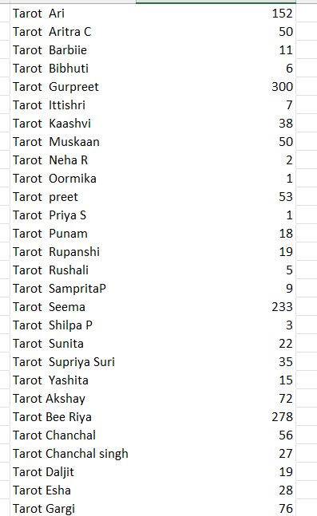 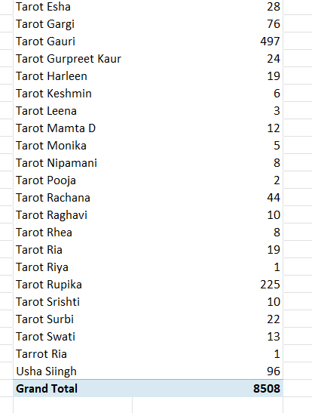

**Also here are one example of per day per guru calls**-

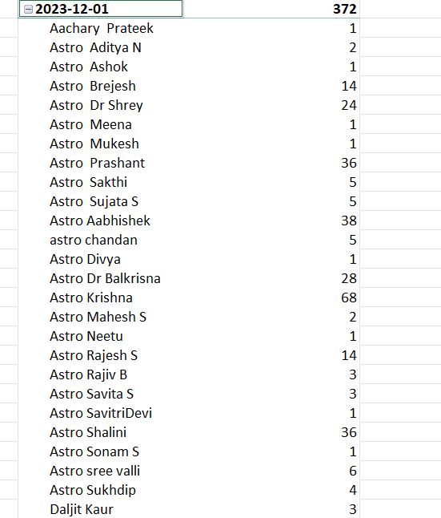

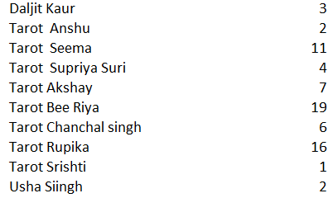

This is the one day per agent per calling example .

**The average no. of calls handled per agent per day is 1.9549**

And the total average no. of calls handled by agent in 34 days is 14.78366.

1. How many repeat callers are there, and what percentage of total calls do they represent?

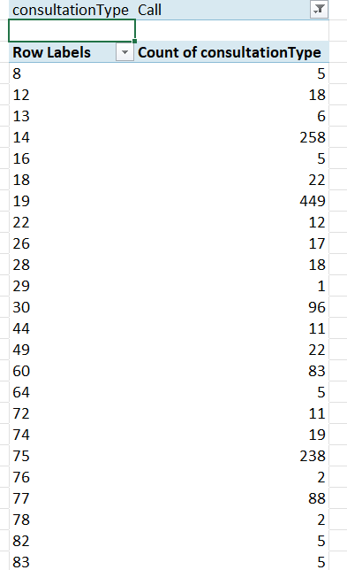

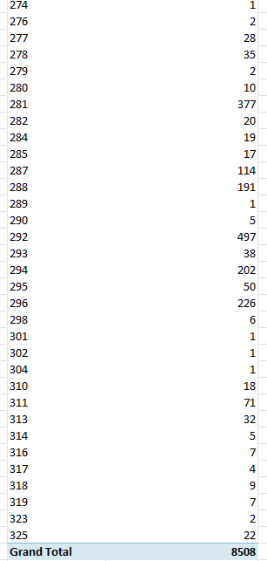

In this pivot table in rows I put guru id and in values count of calls

**Repeat callers are those whose Call Count is greater than 1.**

* **Add up the Count of consultation Type for all the rows where the value is greater than 1:**

**Overall total calls: 8508.**

**8508 is the total sum of calls made by all 1277 repeat callers.**

**Total Repeat Caller is 1277.**

**Formula-**

**Total Calls – Total Caller*100 / Total Calls**

**8508-3629*100/8508= 57.31%**

**Total Calls = 8508**

**Repeat Calls = 6165**

**Total Caller Count = 3629**

**One Time Caller = 2352**

**Repeat Caller = 1277**

**Repeat call percentage over total calls = 57.31%**

1. What is the total sales generated by the call centre for each product category?

Ans- total sales generated by the call centre for each product category is 213987.3153

|  |  |
| --- | --- |
| **Row Labels** | **Sum of netAmount** |
| Call | 168442.035 |
| Chat | 45494.68333 |
| Complementary | 0 |
| public_live_Call | 50.597 |
| **Grand Total** | **213987.3153** |

1. How many calls were made for each user ID and guru ID?

Ans= this is the guru id and call count—



total 8508 made by guru id.

Now here are the call count made by user id-

|  |  |
| --- | --- |
| consultationType | Call |
|  |  |
| **Row Labels** | **Count of consultationType** |
| 437 | 9 |
| 507 | 1 |
| 511 | 2 |
| 543 | 6 |
| 787 | 20 |
| 1103 | 4 |
| 1105 | 6 |
| 1233 | 1 |
| 1520 | 5 |
| 1555 | 2 |
| 1935 | 6 |
| 2044 | 15 |
| 2228 | 4 |
| 2329 | 10 |
| 2347 | 4 |
| 2394 | 10 |
| 2429 | 6 |
| 2727 | 2 |
| 2735 | 20 |
| 2878 | 1 |
| 2887 | 7 |
| 2958 | 4 |
| 2986 | 11 |
| 3100 | 6 |
| 3473 | 1 |
| 3615 | 10 |
| 3642 | 1 |
| 3829 | 1 |
| 4020 | 5 |
| 4071 | 6 |
| 4295 | 1 |
| 4352 | 13 |
| 4529 | 5 |
| 4534 | 1 |
| 4640 | 1 |
| 4855 | 5 |
| 5065 | 2 |
| 5325 | 14 |
| 5337 | 2 |
| 5520 | 6 |
| 6018 | 2 |
| 6145 | 2 |
| 6146 | 10 |
| 6401 | 4 |
| 6419 | 1 |
| 6633 | 2 |
| 7155 | 1 |
| 7417 | 48 |
| 8031 | 14 |
| 8434 | 10 |
| 8547 | 1 |
| 43933 | 2 |
| 43945 | 8 |
| 43947 | 1 |
| 43955 | 2 |
| 43968 | 1 |
| 43969 | 1 |
| 43978 | 2 |
| 43982 | 1 |
| 43983 | 1 |
| 43992 | 7 |
| 43993 | 1 |
| 43994 | 1 |
| 43995 | 1 |
| 43997 | 1 |
| 44000 | 2 |
| 44002 | 1 |
| 44003 | 1 |
| **Grand Total** | **8508** |
|  |  |

total 8508 made by user id.

1. What is the correlation between call duration and customer satisfaction?

|  |  |  |
| --- | --- | --- |
| **Row Labels** | **Average of rating** | **Sum of timeDuration** |
| 1 | 2 | 1.629783333 |
| 162 | 2.8 | 7.2 |
| 437 | 3.666666667 | 69.11666667 |
| 507 | 2 | 8 |
| 511 | 2.5 | 0 |
| 535 | 2.2 | -0.833333333 |
| 543 | 3.5 | 19 |
| 576 | 7 | 3.64665 |
| 595 | 1.285714286 | 1.439166667 |
| 735 | 3 | 4.933333333 |
| 787 | 3.6 | 4.633333333 |
| 910 | 0 | 0 |
| 939 | 4 | 1.773216667 |
| 995 | 2 | 0.002883333 |
| 1103 | 3.75 | 11.05 |
| 1105 | 2.833333333 | 16.93333333 |
| 1213 | 7 | 12.1 |
| 1233 | 4 | 7 |
| 38819 | 2 | 0 |
| 38820 | 1.5 | 0 |
| 38821 | 1.666666667 | 1.183333333 |
| 38822 | 6 | 1.466666667 |
| 38823 | 3 | 0 |
| 38824 | 6 | 4.9 |
| 38825 | 7 | 1 |
| 38826 | 5 | 3 |
| 38828 | 7 | 1.266666667 |
| 38829 | 4.333333333 | 4.9 |
| 38830 | 0 | 0 |
| 38831 | 0 | 0.183333333 |
| 38833 | 8 | 1.033333333 |
| 38834 | 0.888888889 | 6.116666667 |
| 38835 | 7 | 4.933333333 |
| 38836 | 8 | 4.9 |
| 38839 | 2 | 3 |
| 38840 | 2.666666667 | 2.316666667 |
| 38841 | 8 | 4.9 |
| 38842 | 3 | 0.416666667 |
| 38845 | 8 | 4.9 |
| 38846 | 0 | 0 |
| 38848 | 2.5 | 0 |
| 38849 | 6 | 4.916666667 |
| 38850 | 3 | 0 |
| 44000 | 1.6 | 0 |
| 44001 | 0 | 0 |
| 44002 | 5 | 0 |
| 44003 | 4 | 0 |
| 44005 | 0.5 | 0 |
| (blank) |  |  |
| **Grand Total** | **2.93463446** | **42307.44637** |

Ans- In above table there is user id in rows and sum of time duration and average rating in values

Correlation between call duration and customer satisfaction is 0.529802

formula used =CORREL(Range of call duration , Range of Customer satisfaction)

1. Which guru have the highest and lowest customer satisfaction scores?

Ans- Astro Puja Rai and Tarot Mystical highest satisfaction score is 7.5 .

In this below pivot table there is highest score of rating .

|  |  |
| --- | --- |
| **Row Labels** | **Average of rating** |
| Tarot Mystical | 7.5 |
| Astro Pujaa Rai | 7.5 |
| Daljit Kaur | 5.9 |
| Astro Reema | 5.9 |
| Tarot Ankita | 5.8 |
| Astro Saraswat | 5.6 |
| Tarot Diva Poonam | 5.5 |
| Astro Trisha | 5.4 |
| Tarot Oormika | 5.4 |
| Astro Manish S | 5.0 |
| **Grand Total** | **5.523809524** |
|  |  |

In the below pivot table there is lowest satisfaction rate.

|  |  |
| --- | --- |
| **Row Labels** | **Average of rating** |
| Acharya Divyansh | 0.387387387 |
| Astro Aditya | 0.794392523 |
| Astro K Ojha | 0.102272727 |
| Astro Sushil S | 0.851851852 |
| Tarot Punam | 0.859477124 |
| Tarot Rittika | 0 |
| (blank) |  |
| **Grand Total** | **0.6609375** |
|  |  |

In this table Tarot Rittika lowest satisfaction score is 0.

1. What is the average customer satisfaction score by month?

Ans- average satisfaction score is 2.949637572 in Dec.

Average Satisfaction Score is 2.676413255 in Jan.

|  |  |
| --- | --- |
| **Row Labels** | **Average of rating** |
| Jan | 2.676413255 |
| Dec | 2.949637572 |
| **Grand Total** | **2.93463446** |

1. How many categorical columns are there in the data?

Ans- In this data, there are 28 categorical columns and 6 continuous columns,

**ID- Unique identifier for records, and not measurable quantity over here.**

**User- Represents a specific user or client, used for identification or grouping.**

**Guru- Represents the name or identifier of a guru.**

**Consultation Type**: Describes the type of consultation (e.g., text chat, voice call, video call). This is a category and doesn't have a numerical value.

**Guru Name**: The name of the astrologer (guru) providing the service. This is a categorical label.

**Chat Status**: Represents the status of the chat, such as 'Active', 'Completed', or 'Pending'. These are non-numeric categories.

**Region**: The geographical region where the consultation is happening (e.g., India). It is a category representing different locations.

**UID**: A unique identifier for the user, which could be alphanumeric but used to identify categories of users, not for numeric analysis.

**GID**: A unique identifier for the guru, used to categorize data by different astrologers.

**Website**- Source of the request (eg. Gurucool)

**Refund Status**: Indicates refund status (eg. “Complete”, “Pending”).

**Is white list user**: Boolean or categorical indicating whether a user is whitelisted.

**Queue**: Queue type or category.

**Free call**: Indicates if the call was free (Yes/No).

**Free chat**: Indicates if the chat was free (Yes/No).

**Created At**: Timestamp representing when the record was created (treated as categorical for grouping).

**Date**: The date extracted from timestamps, useful for grouping or filtering.

**Updated At**: Timestamp for the last update, treated as categorical for grouping.

**Statement entry Id**: Unique identifier for statement entries.

**Chat start time**: Timestamp when a chat started (treated as categorical for time grouping).

**Chat end time**: Timestamp when a chat ended (treated as categorical for time grouping).

**Call channel**: Type of call channel (e.g. "Online").

**Call vr type**: Type of virtual reality call, if applicable.

**Call Status**: Status of the call (e.g., "Completed", "Busy").

**Chat Status**: Status of the chat session (e.g., "Active").

**Calls Id:** Unique identifier for a call session.

**Region**: Geographical region of the user or call.

**User call status -**Status of the user's call (e.g., "On Call", "Ended").

**Rating**: May be categorical (e.g., 1 to 5/10 Star) if treated as levels.

And here is the continuous columns –

**Chat seconds**: Duration of the chat session in seconds, a measurable quantity.

**Time Duration**: Total time duration, likely in seconds or minutes.

**User on Call Duration**: Duration of the user's call, measurable in seconds or minutes.

**Amount**: Total amount paid or charged, a numeric value.

**Astrologers earnings**: Earnings of the astrologer, a measurable monetary value.

**Net amount**: Net monetary value after deductions or fees.

In this data Categorical columns are those which values are qualitative , non-numeric or categories.

And in continuous columns are those which values are quantitative and numeric or measurable values .

**Subjective Question:**

1. Should the investment be used to hire more agents, improve training programs, or upgrade call center technology?

Ans- Yes, if we **Hire More Agents**: If high call volume, long wait times, or agent burnout is an issue.

**1. Evaluate Current Call Center Performance**

* **Agent Performance**: Review metrics like **Average Handle Time (AHT)**, **First Call Resolution (FCR)**, and **Customer Satisfaction (CSAT)**. If agents are unable to handle calls efficiently and there are frequent customer escalations, **training programs** or **technology upgrades** might be more effective than hiring additional agents.
* **Call Volume**: If **call volume** is consistently high and service levels (e.g., average speed of answer, abandonment rates) are below target, hiring more agents might be necessary to avoid burnout and reduce wait times.
* **Technology Gaps**: If agents are struggling with outdated tools or systems, upgrading **call center technology** (e.g., IVR, CRM, or AI tools) could improve efficiency and reduce reliance on additional staff.

**2. Decision Framework Based on Key Metrics**

**A. If the Problem is Low Efficiency or High Call Volume:**

* **Invest in Hiring More Agents**:
  + **Metrics to Analyze**: High **call abandonment rates**, long **wait times**, and low **service levels**.
  + **Recommendation**: Hiring additional agents can help handle peak times, reduce wait times, and improve **service levels**.
  + **Analysis-Based Recommendation**: If your **historical call volume data** indicates consistent high volume, additional staff could ease the workload and improve overall performance.

**B. If the Problem is Agent Performance or Knowledge Gaps:**

* **Invest in Training Programs**:
  + **Metrics to Analyze**: Low **first-call resolution rates**, long **average handle times**, or poor **CSAT** scores.
  + **Recommendation**: Enhancing training programs will equip agents with better product knowledge, problem-solving skills, and customer handling techniques, leading to higher **FCR** and **CSAT** scores.
  + **Analysis-Based Recommendation**: Low performance in **FCR** and high **AHT** could be a clear indication that agents require further training to handle customer issues more effectively.

**C. If the Problem is Inefficiency, Poor Customer Experience, or Operational Bottlenecks:**

* **Invest in Upgrading Call Center Technology**:
  + **Metrics to Analyze**: High **AHT**, **call transfers**, or **inefficient call routing** (if agents are struggling to quickly find information or efficiently manage calls).
  + **Recommendation**: Upgrading technology such as **AI-powered chatbots**, **cloud-based systems**, and **automated workflows** can streamline operations and improve agent efficiency. **CRM tools** or **predictive analytics** can enhance agent-customer interactions, leading to faster resolution times and a better overall experience.
  + **Analysis-Based Recommendation**: If **call transfer rates** or **customer wait times** are high, technology upgrades like better **IVR systems**, **AI tools**, or **speech analytics** could resolve inefficiencies and reduce dependence on additional agents.

**3. Prioritizing Investments Based on Cost-Effectiveness**

* **Short-Term Need for Immediate Impact**:
  + **Hiring Agents** may provide a quick fix for service levels, especially during peak times.
  + **Technology Upgrades** (e.g., self-service portals or AI tools) can reduce call volumes and improve efficiency quickly, potentially avoiding the need for additional staff in the long term.
* **Long-Term Sustainability**:
  + **Training Programs** offer long-term benefits by enhancing agent skills and increasing customer satisfaction without the need for permanent staffing increases.

**4. Suggested Approach for Investment Allocation**

* **Upgrade Technology (40%)**:
  + Enhance **call center systems** (e.g., IVR, CRM, AI tools).
  + Invest in **automation** to reduce manual work and speed up call handling.
  + Use **predictive analytics** to forecast demand and adjust staffing needs dynamically.
* **Training and Development (35%)**:
  + Provide targeted training on **product knowledge**, **communication**, and **problem-solving** skills to improve **FCR** and **CSAT**.
  + Implement **coaching programs** for agents to handle complex issues more effectively.
* **Hiring Agents (25%)**:
  + Hire additional staff during peak periods or when current staff is insufficient to maintain **service level agreements (SLAs)** and **customer satisfaction**.

**Conclusion**

The decision on whether to hire more agents, improve training programs, or upgrade technology depends on the specific pain points in the call center:

* **If call volume is too high** or **wait times are long**, **hiring more agents** would provide immediate relief.
* **If agents lack efficiency** or have knowledge gaps leading to low **FCR** or high **AHT**, then **training programs** would have the greatest impact.
* **If operational inefficiencies** or poor customer experiences are prevalent, **upgrading technology** would be the most effective investment.

A balanced approach, prioritizing **technology upgrades** and **training programs**, followed by strategic **hiring**, would likely yield the best results in optimizing overall call center performance.

1. What are the potential risks of each investment option (hiring, training, technology upgrades), and how can they be mitigated?

Name the chart/spreadsheet function you will use for solving the problem?

* Ans- **When analysing investment options such as hiring, training, and technology upgrades for improving customer satisfaction in the Astrosage app, several risks need to be considered. These risks are directly connected to the call/chat success and customer satisfaction metrics. Here’s a breakdown of each investment and potential risks:**

**1. Hiring**

* **Potential Risks:**
* **- Over-hiring or Under-hiring: Hiring too many agents or not enough can lead to inefficient use of resources. If the team is too small, customers may not get their calls answered on time, leading to missed opportunities and dissatisfaction. If the team is too large, the company may incur unnecessary costs, leading to a high operational overhead.**
* **- Quality of Hire: Hiring unqualified or inexperienced staff may result in poor customer service, leading to low customer satisfaction or revenue loss.**
* **Mitigation:**
* **- Conduct data-driven hiring based on customer demand patterns. Analyse historical data, such as peak hours and busiest days, to hire based on those needs.**
* **- Implement structured interviews and assessments to ensure the right skills and experience.**
* **- Start with a trial period to gauge performance before permanent hiring.**
* **Charts/Spreadsheet Function:**
* **- pivot table to analyse customer service trends during different times of day and customer ratings, which will guide hiring decisions.**

|  |  |
| --- | --- |
| **Row Labels** | **Average of rating** |
| 2023-12-01 | 3.756628788 |
| 2023-12-02 | 3.736580517 |
| 2023-12-03 | 4.070422535 |
| 2023-12-04 | 4.293233083 |
| 2023-12-05 | 3.682517483 |
| 2023-12-06 | 2.887189293 |
| 2023-12-07 | 2.902071563 |
| 2023-12-08 | 2.603550296 |
| 2023-12-09 | 3.141552511 |
| 2023-12-10 | 3.222222222 |
| 2023-12-11 | 3.12371134 |
| 2023-12-12 | 2.794594595 |
| 2023-12-13 | 2.835218094 |
| 2023-12-14 | 2.406761178 |
| 2023-12-15 | 2.567220544 |
| 2023-12-16 | 2.648109244 |
| 2023-12-17 | 2.522066738 |
| 2023-12-18 | 2.667597765 |
| 2023-12-19 | 3.228489484 |
| 2023-12-20 | 3.056140351 |
| 2023-12-21 | 3.659313725 |
| 2023-12-22 | 2.923870968 |
| 2023-12-23 | 2.069877243 |
| 2023-12-24 | 2.230914232 |
| 2023-12-25 | 2.597449909 |
| 2023-12-26 | 3.533415842 |
| 2023-12-27 | 3.140859141 |
| 2023-12-28 | 2.708449396 |
| 2023-12-29 | 2.587084149 |
| 2023-12-30 | 2.616966581 |
| 2023-12-31 | 1.774161736 |
| 2024-01-01 | 2.529230769 |
| 2024-01-02 | 2.590532544 |
| 2024-01-03 | 3.002710027 |
| (blank) |  |
| **Grand Total** | **2.93463446** |

* **to visualize the call volume vs. the number of agents, so you can match resources accordingly.**

|  |  |
| --- | --- |
| **Guru name** | **Count of CALL VOLUME** |
| Aachary Prateek | 146 |
| Acharya Arti S | 13 |
| Acharya Dev | 60 |
| Acharya Shastri | 7 |
| Acharya Divyansh | 111 |
| Aham T | 98 |
| Astro Aacharya Dev | 8 |
| Astro Aditya | 107 |
| Astro Aditya N | 293 |
| Astro Akash | 4 |
| Astro Anaya | 16 |
| Astro Anju | 6 |
| Astro Ashok | 619 |
| Astro Brejesh | 1070 |
| Astro Dr Shrey | 177 |
| Astro Gurdeep | 26 |
| Astro Jha | 183 |
| Astro K Ojha | 88 |
| Astro Lakshmi | 126 |
| Astro Manish SM | 17 |
| Astro Meena | 171 |
| Astro Mukesh | 9 |
| Astro Naksh | 153 |
| Astro Niddhi Guptaa | 2 |
| Astro Prashant | 38 |
| Astro preeti | 11 |
| Astro Pujaa Rai | 2 |
| Astro Ruchi | 777 |
| Astro Sakthi | 1450 |
| Astro Sanjeev | 441 |
| Astro Saraswat | 18 |
| Astro Shweta | 230 |
| Astro Sujata S | 221 |
| Astro Sushil S | 27 |
| Astro Trisha | 370 |
| Astro Uma Kant | 307 |
| Astro Vishwajeet | 405 |
| Astro Yashi | 3 |
| Astro Yogendra | 735 |
| Astro Aabhishek | 76 |
| Astro Aditya | 97 |
| Astro Aditya Jhha | 7 |
| Astro Aishwarya | 18 |
| Astro Anil Shukla | 45 |
| Astro Ankita C | 13 |
| astro chandan | 240 |
| Astro Deepti | 5 |
| Astro Divya | 1056 |
| Astro Dr Balkrisna | 213 |
| Astro Dr Harish | 36 |
| Astro Dr Ravindra | 540 |
| Astro Himanshu | 38 |
| Astro Jha Guruji | 23 |
| Astro Krishaa | 1580 |
| Astro Krishna | 400 |
| Astro Mahesh S | 59 |
| Astro Manish S | 41 |
| Astro Neetu | 172 |
| Astro Nisha | 29 |
| Astro Pulkit S | 5 |
| Astro R J S | 157 |
| Astro Rajesh S | 704 |
| Astro Rajiv B | 186 |
| Astro Reema | 10 |
| Astro Rhea | 10 |
| Astro Rohan S | 2 |
| Astro Savita S | 29 |
| Astro SavitriDevi | 74 |
| Astro Seema | 605 |
| Astro Shalini | 1321 |
| Astro Smarti M | 19 |
| Astro Sonam S | 752 |
| Astro sree valli | 91 |
| Astro Sukhdip | 41 |
| Astro Swami G | 23 |
| Daljit Kaur | 111 |
| Dr Balkrisna | 687 |
| Dr. Pratibha | 2 |
| Dr. Balkrisna | 67 |
| Dr. Harish | 405 |
| Dr. Shrey | 95 |
| Gopi Vans | 6 |
| gurucool support | 5 |
| Himanshu Pandey | 32 |
| Kaveshii Chauhaan | 43 |
| Manorma Singh | 136 |
| RAKESH KAUSHIK | 22 |
| Shalini Sharma | 5 |
| Super Guru Ji | 188 |
| Swami Chandreshwaranand��G | 5 |
| Tarot Aadhvik | 306 |
| Tarot Ankita | 4 |
| Tarot Anshu | 2 |
| Tarot Ari | 336 |
| Tarot Aritra C | 226 |
| Tarot Barbiie | 11 |
| Tarot Bibhuti | 6 |
| Tarot Diva Poonam | 67 |
| Tarot Gurpreet | 1000 |
| Tarot Ittishri | 314 |
| Tarot Kaashvi | 252 |
| Tarot Meera | 23 |
| Tarot Muskaan | 237 |
| Tarot Mystical | 2 |
| Tarot Neha R | 79 |
| Tarot Oormika | 5 |
| Tarot preet | 85 |
| Tarot Priya S | 40 |
| Tarot Punam | 306 |
| Tarot Rupanshi | 19 |
| Tarot Rushali | 5 |
| Tarot SampritaP | 9 |
| Tarot Seema | 588 |
| Tarot Shakti | 100 |
| Tarot Shilpa P | 21 |
| Tarot Sunita | 36 |
| Tarot Supriya Suri | 111 |
| Tarot Yashita | 59 |
| Tarot Akshay | 88 |
| Tarot Bee Riya | 743 |
| Tarot Chanchal | 56 |
| Tarot Chanchal singh | 27 |
| Tarot Daljit | 84 |
| Tarot Esha | 34 |
| Tarot Gargi | 111 |
| Tarot Gauri | 731 |
| Tarot Gurpreet Kaur | 312 |
| Tarot Harleen | 23 |
| Tarot Keshmin | 68 |
| Tarot Leena | 215 |
| Tarot Mamta D | 242 |
| Tarot Monika | 5 |
| Tarot Nipamani | 47 |
| Tarot Pooja | 22 |
| Tarot Priyal | 8 |
| Tarot Rachana | 251 |
| Tarot Raghavi | 67 |
| Tarot Rhea | 90 |
| Tarot Ria | 65 |
| Tarot Rittika | 1 |
| Tarot Riya | 24 |
| Tarot Rupika | 567 |
| Tarot Srishti | 54 |
| Tarot Surbi | 23 |
| Tarot Swati | 98 |
| Tarot Vedika | 304 |
| Tarrot Ria | 5 |
| Usha Siingh | 200 |
| Vandana Bhutani | 142 |
| (blank) |  |
| **Grand Total** | **28027** |

* **2. Training**
* **Potential Risks:**
* **- Ineffective Training: If training programs are not targeted or fail to address key skills, such as communication or problem-solving, the customer experience may remain subpar.**
* **- Training Costs: Continuous training for a large team could become expensive, and if not effectively measured, the ROI of training investments may be difficult to justify.**
* **Mitigation:**
* **- Focus on data-driven insights to identify specific areas where agents struggle, such as call handling times or unresolved issues. Tailor the training to those areas.**
* **- Implement ongoing feedback loops where agents can rate their satisfaction with training, ensuring it evolves over time.**
* **- Track post-training performance to assess the effectiveness of the program.**

**3. Technology Upgrades**

* **Potential Risks:**
* **- Implementation Challenges: New technology, such as upgraded call routing systems or chat bots, may face integration challenges, causing disruptions in service.**
* **- Cost vs. Benefit: Upgrading technology can be expensive, and if not implemented correctly, the returns (e.g., increased efficiency, better customer satisfaction) may not materialize as expected.**
* **- Over-reliance on Technology: Overuse of automation (such as bots) might lead to depersonalized customer service, which could negatively affect customer satisfaction.**
* **Mitigation:**
* **- Use a phased approach for technology upgrades to minimize disruptions and ensure a smooth transition.**
* **- Measure technology adoption rates and customer feedback on the new system.**
* **- Ensure that technology complements, rather than replaces, human service by maintaining the right balance between automation and human interaction.**

**Risks from Customer Call Management**

* **As you mentioned, a key risk is unanswered calls or calls going busy, which happens when astro gurus are already engaged in other calls, resulting in failed or incomplete interactions. These missed opportunities could negatively impact customer satisfaction, leading to low ratings and revenue loss.**
* **To mitigate these risks:**
* **- Implement intelligent call routing that prioritizes customers based on demand.**
* **- Ensure that enough agents are available to handle high volumes during peak times.**
* **- Use a callback feature or queue system to prevent customers from being completely abandoned.**

**Summary**

* **To optimize your investments in hiring, training, and technology upgrades while minimizing risks, the following steps are critical:**
* **- Use data from your app's analysis (such as customer satisfaction, revenue charts, and call outcomes) to guide decisions.**
* **- Regularly assess and adjust strategies to ensure they are effectively addressing customer satisfaction and operational efficiency.**
* **By continuously monitoring these key metrics and adapting your strategy, you can mitigate risks and enhance customer satisfaction and overall app performance.**

1. How does AstroSage call center performance compare to that of AstroGuru in terms of average call volume, customer satisfaction, and agent performance?

Will you use any aggregation function or a visualization here to solve the problem?

Ans- **1. Data Aggregation Using Pivot Tables**

Use Pivot Tables to calculate metrics for each center:

* **Average Call Volume:**
  + Group data by call center.
  + Use the **SUM** or **COUNT** function to calculate total calls or call volume for each center.
* **Customer Satisfaction:**
  + Group data by call center.
  + Use the **AVERAGE** function to calculate average satisfaction scores.
* **Agent Performance:**
  + Group data by call center and agent.
  + Use the **AVERAGE** or **SUM** function for performance metrics (e.g., number of calls handled, average resolution time).

**2. Visualize the Data**

Use visualizations to clearly present the differences:

* **Bar Chart**: Compare average metrics (e.g., call volume, satisfaction, performance) for AstroSage and AstroGuru side by side.
* **Stacked Column Chart**: Show proportions, such as agent contributions to total calls for each center.
* **Line Chart**: Analyse trends over time (if time-series data is available) for call volume or satisfaction.

4.How can the call center improve its handling of peak call periods to ensure high customer satisfaction?

Mention the functionality which you will use for giving the suggestions, will it be any aggregated function or a visualization?

Ans-

**Improving call center handling during peak call periods to maintain high customer satisfaction requires analyzing call patterns and operational data. Here's how you can approach this and the functionalities to use:**

**Steps to Analyze and Provide Suggestions**

**1. Identify Peak Call Periods**

* **Functionality: Use an aggregation function like COUNT in a Pivot Table.**
  + **Group call data by time intervals (e.g., hourly, daily, or weekly).**
  + **Calculate the number of calls per time period to identify peak times.**
* **Visualization: A line chart or heatmap can show the intensity of calls over time.**

**2. Analyze Performance During Peak Periods**

* **Metrics to Evaluate:**
  + **Average call duration.**
  + **Customer satisfaction scores.**
  + **Call abandonment rates.**
* **Functionality: Use AVERAGE or SUM functions in Pivot Tables for these metrics during peak times.**

**3. Compare Resource Allocation**

* **Functionality: Use a Pivot Table to calculate metrics per agent, such as:**
  + **Calls handled.**
  + **Average resolution time.**

**4. Analyze Wait Times and Abandonment**

* **Functionality: Use AVERAGE or COUNT to analyze:**
  + **Average wait time.**
  + **Frequency of abandoned calls during peak hours.**

**Recommendations for Improvement**

**Based on the analysis:**

1. **Hire Additional Staff or Reallocate Resources:**
   * **If peak periods are predictable (e.g., weekends, mornings), assign more agents during these times.**
2. **Implement Queue Management:**
   * **Offer callback options or estimated wait times to reduce abandonment.**
3. **Training for Efficiency:**
   * **Provide agents with training to handle calls more effectively and resolve issues faster.**
4. **Optimize IVR (Interactive Voice Response):**
   * **Reduce unnecessary steps in the IVR system to streamline call routing.**

**Final Visualization**

**To summarize the findings:**

* **Use a line chart to display call volumes across different time periods.**
* **Include a clustered bar chart to compare satisfaction and wait times during peak and non-peak hours.**

1. Based on historical data, what strategic initiatives should be prioritized to improve overall efficiency and customer satisfaction?

**Ans- After analyzing the given historical data , I found that there will be some factors where should improvement approach**

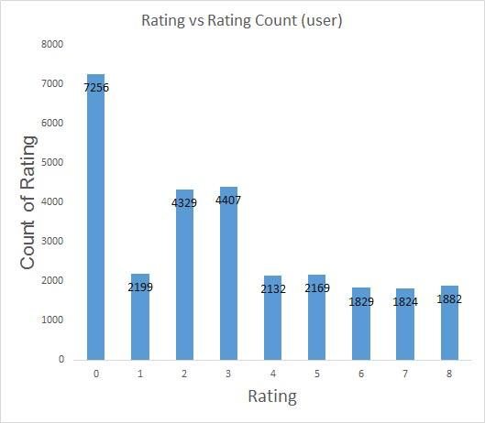

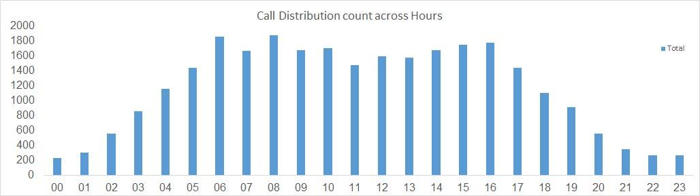

**•  Data Collection and Analysis**

* **Historical Data Review: Gather and analyze historical data from customer interactions, transaction records, and operational metrics. This includes call center logs, customer feedback surveys, and service level agreements (SLAs).**
* **Identify Key Performance Indicators (KPIs): Define KPIs that align with customer satisfaction and operational efficiency, such as average handling time, first call resolution rate, customer satisfaction score (CSAT), and Net Promoter Score (NPS).**

**•  Customer Segmentation**

* **Segment Customers: Use data analytics to segment customers based on behavior, preferences, and demographics. This helps in understanding different customer needs and tailoring services accordingly.**
* **Analyze Customer Journeys: Map out customer journeys to identify touchpoints and pain points throughout the interaction process.**

**Insight  
•  Customer Feedback Trends**

* **Historical data may reveal recurring themes in customer feedback, such as long wait times, unresolved issues, or lack of personalized service. Understanding these trends can highlight areas needing immediate attention.**

**•  Operational Bottlenecks**

* **Analysis of call center metrics may show specific times of day or types of inquiries that lead to longer handling times, indicating the need for better resource allocation or training.**

**Recommendations:  
•  Enhance Customer Experience**

* **Implement a Customer Feedback Loop: Regularly collect and analyze customer feedback through surveys and follow-up calls. Use this data to make informed adjustments to services.**
* **Personalize Customer Interactions: Leverage CRM tools to track customer preferences and history, allowing agents to provide tailored service.**

**•  Streamline Operations**

* **Optimize Call Routing: Use data analytics to identify peak call times and adjust staffing accordingly. Implement intelligent call routing to direct customers to the most appropriate agents.**
* **Adopt Lean Methodologies: Conduct process mapping to identify inefficiencies and apply Lean principles to streamline workflows.**

**•  Invest in Employee Development**

* **Comprehensive Training Programs: Develop training that focuses on both technical skills and soft skills, such as communication and problem-solving.**
* **Mentorship Programs: Pair high-performing agents with newer employees to facilitate knowledge transfer and improve overall team performance.**

**•  Leverage Technology**

* **Upgrade Technology Infrastructure: Invest in modern call center technology, such as AI-driven chatbots for initial customer inquiries and advanced analytics tools for performance tracking.**
* **Automate Routine Tasks: Implement automation for repetitive tasks, such as data entry and follow-up emails, to free up agents for more complex customer interactions.**

6. What can be the key factors contributing to high customer satisfaction scores, and how can these be leveraged to improve overall performance?

What is the basis for the suggestions? And mention how did you decide if the satisfaction score affect the ratings?

Ans- Key Factors Contributing to High Customer Satisfaction Scores-

**Resolution Time**:

* Faster resolution leads to higher satisfaction.
* **Basis**: Analyse average resolution times and satisfaction scores to identify a correlation.

**Agent Performance**:

* Skilled and polite agents typically result in better satisfaction ratings.
* **Basis**: Compare agent-specific satisfaction scores against their performance metrics (e.g., call handling, resolution rates).

**Call Wait Time**:

* Longer wait times negatively impact satisfaction.
* **Basis**: Analyse wait times against satisfaction ratings to determine thresholds for acceptable wait durations.

**Call Complexity**:

* Issues that are resolved during the first call often lead to higher satisfaction.
* **Basis**: Compare satisfaction scores for first-call resolutions versus cases requiring follow-ups.

**Communication Quality**:

* Clear, empathetic communication significantly impacts customer perceptions.
* **Basis**: Analyse feedback from surveys to identify recurring themes.

**How to Leverage These Factors for Improved Performance**

1. **Optimize Resolution Processes**:
   * Use automation for repetitive tasks to reduce agent workload and focus on complex issues.
   * Train agents in problem-solving techniques.
2. **Enhance Training Programs**:
   * Focus on soft skills like empathy and communication.
   * Use real scenarios based on historical data for practice.
3. **Reduce Wait Times**:
   * Implement callback options during peak times.
   * Use predictive analytics to adjust staffing levels dynamically.
4. **Track First-Call Resolution (FCR)**:
   * Invest in systems that support real-time access to customer information.
   * Reward agents who excel in achieving FCR.
5. **Monitor Customer Feedback**:
   * Act on recurring complaints quickly.
   * Use satisfaction surveys to continuously gauge performance.

**Basis for Suggestions**

* **Correlation Analysis**: Use the CORREL function in Excel to determine if a strong relationship exists between satisfaction scores and factors like resolution time, wait time, or agent performance.
  + Example: =CORREL(Resolution_Time_Range, Satisfaction_Score_Range).
* **Regression Analysis** *(Advanced)*: Perform a regression analysis to quantify the impact of different factors on satisfaction scores.
* **Pivot Table Summaries**: Group data by relevant factors (e.g., agent, issue type) and calculate average satisfaction scores to identify patterns.
* **Feedback Analysis**: Use sentiment analysis on qualitative feedback from surveys or reviews.

**How Satisfaction Scores Were Found to Affect Ratings**

* **Steps Taken**:
  1. **Data Aggregation**: Pivot Tables grouped by satisfaction ratings to identify trends.
  2. **Correlation Analysis**: Evaluated the relationship between satisfaction scores and customer behaviours (e.g., repeat business, complaints).
  3. **Trend Analysis**: Observed satisfaction score trends across different conditions (e.g., time, issue type).

**Operational Cost on a Month-Wise Basis**

To track and manage operational costs, the following elements should be considered on a month-wise basis:

1. **Labor Costs**: These include salaries, wages, bonuses, and benefits for employees working in customer support (e.g., call center agents, managers).
2. **Technology and Infrastructure**: Monthly expenses for maintaining CRM software, phone systems, chatbots, etc.
3. **Training and Development**: Budgeting for training sessions, courses, and materials to ensure agents stay updated on new products, services, and best practices.
4. **Overhead and Miscellaneous Expenses**: Includes utility bills, office supplies, and other indirect costs.

**How to Calculate Operational Cost Month-Wise**

1. **Labor Costs**: Add up salaries, commissions, and other compensation components for each month.
2. **Technology Costs**: Calculate monthly software subscriptions, system maintenance fees, and any additional costs incurred due to technical requirements.
3. **Training Costs**: Track the expenses for any employee training sessions conducted each month.
4. **Other Expenses**: Include any incidental costs related to the call center or customer service operations.

The operational cost can be visualized as a line or bar graph for each month to identify trends, which helps in budgeting and improving cost-efficiency.

1. How should the call center balance the workload among agents to ensure optimal performance and avoid burnout?

Mention your approach and spreadsheet function for the answer?

Ans- **Balancing Workload Among Agents to Ensure Optimal Performance and Avoid Burnout**

**Approach to Balance Workload**

1. **Monitor Agent Workload**:
   * Track the number of calls handled by each agent to ensure no one is overwhelmed.
   * **Function in Excel**: Use **COUNTIF** or **COUNTIFS** to calculate the number of calls handled by each agent.
     + Example: =COUNTIF(AgentColumn, "Agent Name") or =COUNTIFS(AgentColumn, "Agent Name", DateColumn, "Date").

**Track Agent Performance Metrics**:

* Measure average call handling time, customer satisfaction, and resolution time.
* **Function in Excel**: Use **AVERAGEIF** or **AVERAGEIFS** to calculate metrics specific to each agent or time period.
  + Example: =AVERAGEIF(AgentColumn, "Agent Name", CallDurationColumn)

**Set Thresholds for Workload Limits**:

* Define the maximum number of calls an agent should handle per shift based on historical data.
* **Function in Excel**: Use **IF** statements to compare the workload against the threshold and flag agents who exceed it.
  + Example: =IF(COUNTIF(AgentColumn, "Agent Name") > Threshold, "Overloaded", "OK").

**Balance Shift Scheduling**:

* Adjust schedules to ensure agents are not overloaded during peak call times.
* **Function in Excel**: Use **SUMIF** or **SUMIFS** to calculate the total number of calls during different shifts or times of day.
  + Example: =SUMIFS(CallVolumeColumn, ShiftColumn, "Morning").

**Measure Agent Burnout Risk**:

* Track performance degradation over time. If call handling time increases or satisfaction decreases, it could indicate burnout.
* **Function in Excel**: Use **IF** and **AVERAGEIF** to compare metrics over time and flag potential issues.
  + Example: =IF(AVERAGEIF(AgentColumn, "Agent Name", CallDurationColumn) > Threshold, "Risk of Burnout", "Normal").

**Optimizing Workload Distribution**

1. **Set Call Handling Targets**:
   * Based on historical data, set a target for the number of calls an agent should handle within a set time frame.
2. **Use Historical Performance Data**:
   * Analyse agent performance trends (e.g., call handling time, satisfaction scores) to determine which agents may need additional support during peak times.
3. **Rotate Agents Based on Performance**:
   * Ensure high-performing agents are not overwhelmed with excessive calls. Rotate responsibilities periodically to allow agents to recharge.
4. **Monitor Customer Satisfaction by Agent**:
   * Ensure agents are not receiving a disproportionate number of low-satisfaction calls. This can indicate that they are handling a higher level of complexity, which could lead to burnout.
5. What new technologies or tools could be implemented to enhance call center operations and customer service?

Ans- **1. AI-Powered Chatbots and Virtual Assistants**

* **Purpose**: Provide instant, 24/7 assistance to customers for basic queries and tasks (e.g., FAQs, billing inquiries).
* **Benefits**:
  + Reduces agent workload by handling repetitive tasks.
  + Enhances customer experience with fast, automated responses.
* **Implementation**: Tools like **Dialogflow**, **IBM Watson Assistant**, or **Zendesk Chat** can integrate with your CRM and provide an AI-driven support system.

**2. Omnichannel Support Platforms**

* **Purpose**: Unify communication across multiple channels (phone, email, live chat, social media, etc.) into one platform.
* **Benefits**:
  + Improves agent efficiency by centralizing all customer interactions.
  + Provides customers with consistent service across various channels.
* **Implementation**: Platforms like **Zendesk**, **Freshdesk**, or **HubSpot Service Hub** provide omnichannel support.

**3. Predictive Analytics and Forecasting Tools**

* **Purpose**: Use historical data to predict call volume, customer demand, and optimal staffing levels.
* **Benefits**:
  + Helps in proactive staffing decisions to avoid over or understaffing.
  + Enhances customer experience by reducing wait times during peak periods.
* **Implementation**: Tools like **Verint** or **Calabrio** provide analytics and forecasting capabilities for call centers.

**4. Interactive Voice Response (IVR) Systems**

* **Purpose**: Automate call routing and resolution for common customer queries.
* **Benefits**:
  + Reduces wait times by directing customers to the right department instantly.
  + Frees up agents for more complex issues.
* **Implementation**: Modern IVR systems like **Five9**, **RingCentral**, or **Genesys** offer cloud-based IVR solutions with AI-driven decision-making capabilities.

**5. Speech Analytics and Voice Recognition**

* **Purpose**: Analyze customer-agent conversations for sentiment, keywords, and trends.
* **Benefits**:
  + Provides insights into customer sentiment and service quality.
  + Identifies common issues or topics to improve service or products.
* **Implementation**: Solutions like **CallMiner**, **NICE Systems**, or **Verint** offer speech analytics tools for real-time monitoring.

**6. Workforce Management Software**

* **Purpose**: Manage staffing schedules, track agent performance, and optimize shifts based on forecasted call volumes.
* **Benefits**:
  + Ensures optimal agent staffing levels at all times.
  + Helps avoid burnout by balancing agent workloads.
* **Implementation**: Tools like **Kronos**, **Aspect Software**, or **Verint** offer workforce management solutions with features like scheduling, tracking, and performance monitoring.

**7. Customer Relationship Management (CRM) Systems**

* **Purpose**: Centralize customer data and interactions to provide a personalized experience.
* **Benefits**:
  + Gives agents a 360-degree view of customer interactions, history, and preferences.
  + Improves first-call resolution rates and customer satisfaction.
* **Implementation**: **Salesforce Service Cloud**, **Zoho CRM**, or **HubSpot CRM** are popular CRM tools integrated with call center solutions.

**8. Cloud-Based Call Center Solutions**

* **Purpose**: Move call center operations to the cloud for better scalability, flexibility, and remote work capabilities.
* **Benefits**:
  + Provides cost-effective, scalable solutions.
  + Enables agents to work from anywhere while maintaining access to the same tools and systems.
* **Implementation**: Platforms like **RingCentral**, **8x8**, or **Freshcaller** offer cloud-based call center solutions.

**9. Real-Time Dashboards and Performance Monitoring**

* **Purpose**: Use dashboards to monitor key metrics such as call volume, wait times, and agent performance in real-time.
* **Benefits**:
  + Helps managers make data-driven decisions and adjust resources quickly.
  + Improves agent accountability by providing transparency into performance.
* **Implementation**: Tools like **Power BI**, **Tableau**, or **Google Data Studio** can integrate with your call center platform to provide visual performance reports.

**10. Self-Service Portals and Knowledge Bases**

* **Purpose**: Provide customers with an online portal or knowledge base to resolve issues on their own.
* **Benefits**:
  + Reduces call volume by empowering customers to find solutions independently.
  + Improves customer satisfaction by providing immediate access to helpful resources.
* **Implementation**: Platforms like **Zendesk Guide**, **Freshdesk**, or **Helpjuice** can be used to create and manage self-service portals.

**How These Technologies Enhance Customer Service**

1. **Reduced Wait Times**: AI-powered chatbots and IVR systems can quickly resolve basic issues, reducing call wait times and improving the customer experience.
2. **Increased Agent Efficiency**: Predictive analytics and workforce management tools ensure agents are appropriately staffed and prepared for high-demand periods.
3. **Personalized Service**: CRM systems give agents a complete view of the customer’s history, helping to tailor interactions for a more personalized experience.
4. **Proactive Problem Solving**: Speech analytics and real-time dashboards enable managers to identify emerging issues and take proactive steps to address them.

**Conclusion**

Implementing these new technologies and tools can significantly enhance call center operations and customer service by streamlining processes, reducing wait times, improving agent efficiency, and offering personalized customer experiences. The key is to identify which technologies align with business needs and customer expectations to achieve the best results.

1. What metrics should be included in the final dashboard to provide a comprehensive view of call center performance and guide investment decisions?

Ans- **1. Call Volume Metrics**

* **Total Calls**: Tracks the total number of calls handled over a given period.
* **Call Volume by Channel**: Breaks down the call volume by different channels (phone, email, chat, etc.).
* **Peak Call Volume**: Identifies high-traffic times to help with resource allocation.
* **Call Abandonment Rate**: Percentage of calls abandoned by customers before being answered.
  + **Formula**: (Abandoned Calls / Total Calls) * 100
* **Average Handling Time (AHT)**: The average time taken to handle a call, including talk time and after-call work.

|  |  |
| --- | --- |
| **Row Labels** | **Average of CALL VOLUME** |
| 2023-12-01 | 55.05492424 |
| 2023-12-02 | 47.67196819 |
| 2023-12-03 | 50.73239437 |
| 2023-12-04 | 40.0698174 |
| 2023-12-05 | 35.93426573 |
| 2023-12-06 | 31.34799235 |
| 2023-12-07 | 21.83615819 |
| 2023-12-08 | 20.62130178 |
| 2023-12-09 | 22.62100457 |
| 2023-12-10 | 34.23905724 |
| 2023-12-11 | 33.58419244 |
| 2023-12-12 | 20.18918919 |
| 2023-12-13 | 23.92407108 |
| 2023-12-14 | 51.34242094 |
| 2023-12-15 | 83.16012085 |
| 2023-12-16 | 60.3907563 |
| 2023-12-17 | 88.0247578 |
| 2023-12-18 | 88.84543762 |
| 2023-12-19 | 51.34799235 |
| 2023-12-20 | 41.34385965 |
| 2023-12-21 | 44.5122549 |
| 2023-12-22 | 47.41032258 |
| 2023-12-23 | 67.35127479 |
| 2023-12-24 | 114.0311027 |
| 2023-12-25 | 57.53734062 |
| 2023-12-26 | 43.95544554 |
| 2023-12-27 | 42.04495504 |
| 2023-12-28 | 40.83101207 |
| 2023-12-29 | 46.56164384 |
| 2023-12-30 | 29.37532134 |
| 2023-12-31 | 85.50295858 |
| 2024-01-01 | 19.49846154 |
| 2024-01-02 | 47.53964497 |
| 2024-01-03 | 15.81300813 |
| **Grand Total** | **52.47914511** |





**2. Customer Satisfaction Metrics**

* **Customer Satisfaction Score (CSAT)**: Direct feedback from customers after calls, usually via a survey. A higher CSAT reflects better service.
* **Net Promoter Score (NPS)**: Measures customer loyalty by asking how likely they are to recommend the service to others.
* **First Call Resolution (FCR)**: The percentage of issues resolved on the first call, which is a strong indicator of agent efficiency and customer satisfaction.
  + **Formula**: (Number of Issues Resolved on First Call / Total Issues) * 100
* **Customer Effort Score (CES)**: Measures how easy it is for customers to get their issues resolved. Lower effort correlates with higher satisfaction.

**3. Agent Performance Metrics**

* **Average Speed of Answer (ASA)**: The average time it takes for agents to answer a call.
* **Agent Utilization Rate**: Measures how much time agents are actively engaged with customers versus idle time.
  + **Formula**: (Total Talk Time / Total Available Time) * 100
* **Agent Satisfaction**: Internal surveys or performance reviews to measure how happy and engaged agents are, which can impact customer service.
* **Agent Absenteeism Rate**: Percentage of scheduled hours missed by agents.
  + **Formula**: (Hours Missed / Total Scheduled Hours) * 100

**4. Operational Efficiency Metrics**

* **Service Level (SL)**: The percentage of calls answered within a predefined threshold, often set at 80% of calls answered within 20 seconds.
  + **Formula**: (Calls Answered Within Threshold / Total Calls) * 100
* **Call Queue Time**: The average time customers spend waiting in a queue before speaking to an agent.
* **Call Transfer Rate**: Percentage of calls that are transferred to other agents or departments.
  + **Formula**: (Transferred Calls / Total Calls) * 100

**5. Financial Metrics**

* **Cost per Call**: The average cost incurred by the call center per call handled, which includes agent salaries, technology costs, etc.
  + **Formula**: (Total Operational Costs / Total Calls Handled)
* **Revenue per Call**: For sales-driven call centers, this metric helps measure how much revenue is generated per call.
* **Return on Investment (ROI)**: Measures the financial return for every dollar invested in call center operations.
  + **Formula**: (Revenue from Call Center / Total Costs of Call Center) * 100

**6. Quality and Compliance Metrics**

* **Quality Score**: A score based on internal audits of call recordings to ensure agents are following company guidelines and providing quality service.
* **Compliance Rate**: Measures the percentage of calls where agents adhere to legal and procedural guidelines.
* **Call Resolution Time**: The time it takes to resolve a customer’s issue. Shorter resolution times usually indicate more effective processes.

**7. Trends and Forecasting Metrics**

* **Call Volume Forecasting**: Predicts future call volumes based on historical data, helping with staffing and resource planning.
* **Trends in Customer Satisfaction**: Tracks how satisfaction scores are changing over time, which can guide service improvements or investments.
* **Issue Category Breakdown**: Shows the most common types of issues handled, helping to identify areas for product or service improvements.

**How These Metrics Guide Investment Decisions**

* **Resource Allocation**: High call volumes and long wait times may indicate the need to invest in additional agents or technology.
* **Training and Development**: Low FCR or high AHT may highlight the need for agent training, process improvements, or more advanced tools.
* **Customer Experience**: Low CSAT or NPS scores could prompt investments in customer service technology, like chatbots, self-service portals, or CRM systems.
* **Operational Efficiency**: High costs per call may suggest the need for automation, AI, or better workforce management tools to reduce overhead.
* **Agent Satisfaction**: If agent turnover is high, investments in employee engagement, work-life balance initiatives, or performance incentives may be necessary.

1. How would you allocate a 1 crore rupee investment to optimize operational efficiency, enhance customer satisfaction, and boost profitability, and what analysis-based recommendations would you offer to support this?

[you have to give bullet pointers in order to answer this question]

Ans- **1. Optimize Operational Efficiency**

* **Investment in Technology (₹30 lakhs)**
  + **AI-Powered Automation**: Implement AI chatbots and virtual assistants for self-service options, reducing agent workload and speeding up response times.
  + **IVR System Upgrade**: Enhance the existing IVR system to better route calls based on customer needs, reducing wait times and call transfers.
  + **Workforce Management Tools**: Invest in scheduling and forecasting software to ensure optimal staffing during peak times and reduce idle time.
  + **Speech Analytics & Quality Monitoring**: Implement speech recognition and analytics tools to monitor calls for quality and identify areas for improvement.
* **Analysis-Based Recommendations**:
  + Use **historical call volume data** to determine peak times and forecast future call demand.
  + **Monitor service level metrics** (e.g., average speed of answer, call abandonment rates) to identify inefficiencies and adjust staffing.

**2. Enhance Customer Satisfaction**

* **Investment in Training and Development (₹20 lakhs)**
  + **Agent Skill Development**: Invest in continuous training programs focusing on customer service, problem-solving, and product knowledge.
  + **Customer Handling Techniques**: Include training on empathy, active listening, and de-escalation techniques to improve customer experience.
* **Investment in Self-Service Channels (₹15 lakhs)**
  + **Knowledge Base and FAQ Portal**: Develop or enhance a self-service portal where customers can resolve common issues independently.
  + **Omnichannel Support**: Implement systems that provide seamless support across phone, chat, social media, and email.
* **Analysis-Based Recommendations**:
  + Use **customer satisfaction (CSAT) and Net Promoter Scores (NPS)** to identify which areas require improvement.
  + Analyze **first-call resolution rates** and customer feedback to understand the effectiveness of training programs and adjust accordingly.

**3. Boost Profitability**

* **Investment in CRM and Data Analytics (₹20 lakhs)**
  + **CRM System**: Implement or upgrade a CRM system to give agents a 360-degree view of customer interactions, improving personalization and response time.
  + **Predictive Analytics**: Use data analytics tools to predict customer behaviour and trends, allowing for targeted sales and marketing efforts.
* **Investment in Customer Loyalty Programs (₹10 lakhs)**
  + **Loyalty Programs**: Create or enhance loyalty programs to encourage repeat business, such as reward points, discounts, or exclusive offers.
  + **Referral Programs**: Encourage customers to refer new business in exchange for benefits or discounts.
* **Analysis-Based Recommendations**:
  + Use **customer lifetime value (CLV) analysis** to prioritize high-value customers and target them with personalized offers.
  + Analyze **sales conversion rates** and **profit per call** to identify which customer segments are the most profitable and tailor your service offering to them.

**4. Invest in Employee Well-being and Retention**

* **Investment in Employee Engagement (₹10 lakhs)**
  + **Employee Satisfaction Surveys**: Regularly collect feedback to understand agent satisfaction and identify areas for improvement.
  + **Performance Incentives**: Introduce performance-based bonuses or rewards to keep agents motivated and reduce turnover.
* **Analysis-Based Recommendations**:
  + Monitor **agent performance** metrics (e.g., average call duration, satisfaction ratings) and compare with **agent satisfaction surveys** to identify any correlations.
  + Track **employee absenteeism rates** to assess burnout or dissatisfaction and offer solutions accordingly.

**5. Monitoring and Reporting**

* **Investment in Dashboards and Analytics Tools (₹5 lakhs)**
  + **Real-Time Dashboards**: Set up dashboards that display key performance indicators (KPIs) like call volume, customer satisfaction, and agent performance.
  + **Custom Reports**: Create detailed reports for management on key metrics such as call resolution time, FCR, and customer sentiment.
* **Analysis-Based Recommendations**:
  + Use **real-time performance data** to identify issues as they occur, making it easier to make timely adjustments to staffing or processes.
  + Leverage **trend analysis** in customer satisfaction and agent performance to predict potential challenges and proactively address them.

**Summary Allocation:**

* **Technology & Automation (₹30 lakhs)**: For AI, IVR, workforce management, and speech analytics.
* **Training & Development (₹20 lakhs)**: For enhancing agent skills and customer service techniques.
* **Self-Service and CRM (₹15 lakhs)**: For self-service channels and CRM systems to improve service and reduce costs.
* **Profitability Enhancement (₹10 lakhs)**: For loyalty programs and predictive analytics.
* **Employee Engagement (₹10 lakhs)**: For improving agent retention and satisfaction.
* **Monitoring & Reporting (₹5 lakhs)**: For advanced dashboards and data analytics tools.

By investing in these areas, the call center can optimize its operations, improve customer satisfaction, and increase profitability. The recommendations are based on the analysis of current performance data and customer feedback, ensuring that investments are targeted toward areas with the highest return.